Good choices will make my teacher happy.
Good choices will make my friends happy.
I will try to make good choices.
Making Good Choices and Consequences

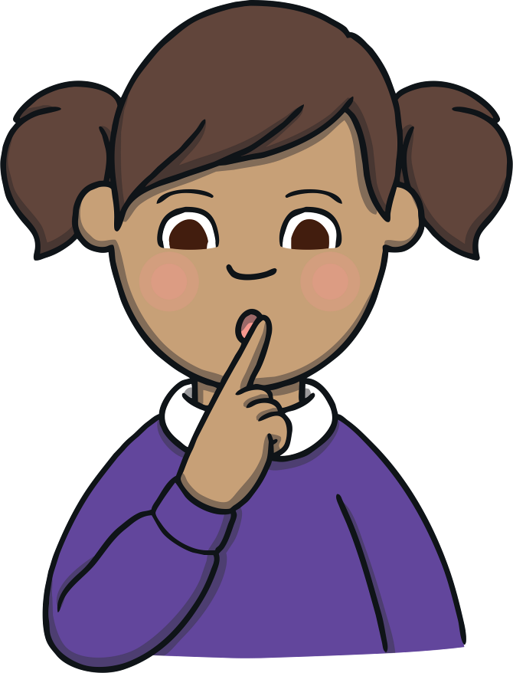

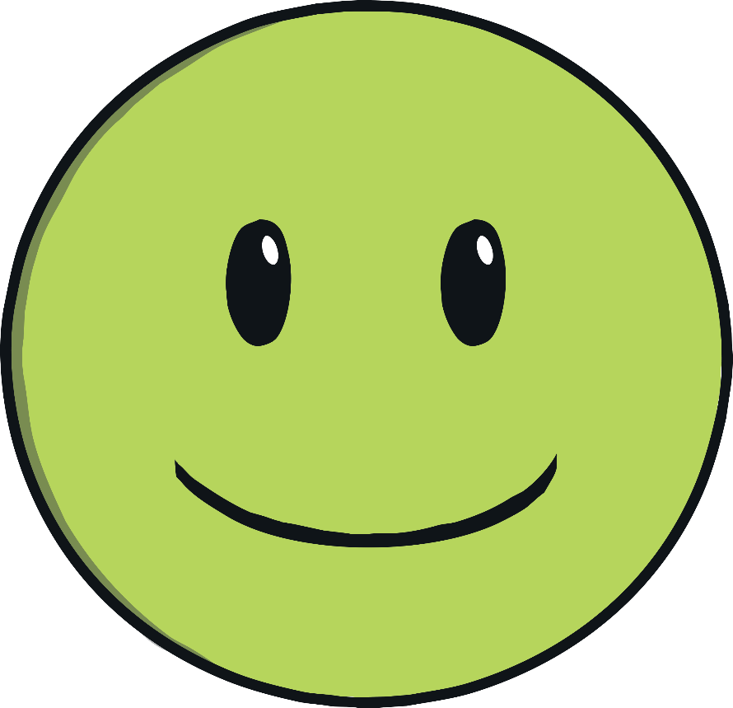

I am learning to make good choices.

Good choices are:
My name is .

My teacher is .

I am years old.

I go to School.

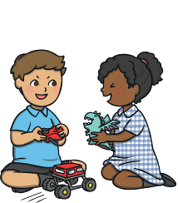
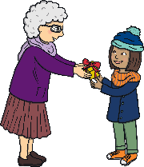
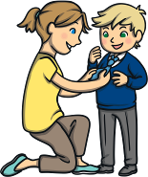
taking turns

helping
being kind

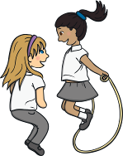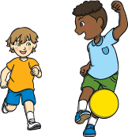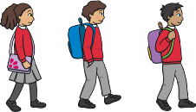
sharing
waiting

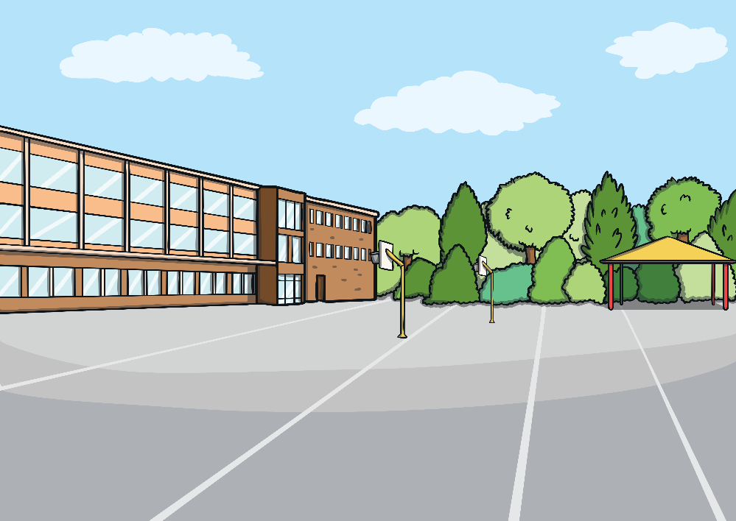
playing nicely

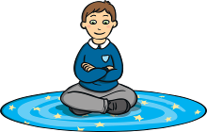

sitting on the carpet nicely

My teacher can help me make good choices.

Circle the good choices:
Sometimes, I make bad choices in school.
Bad choices make my teacher sad.
Bad choices make my friends sad.

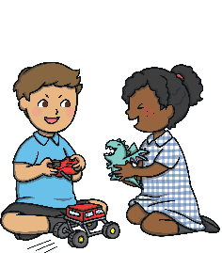
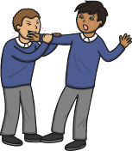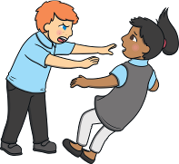
biting
pushing
taking turns
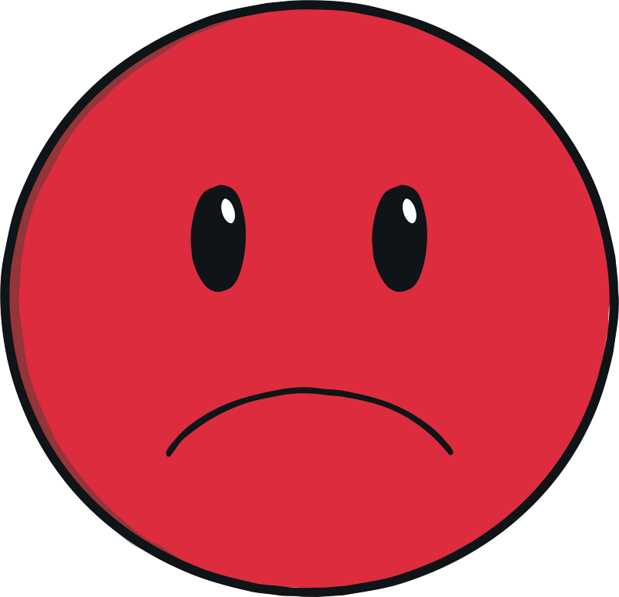

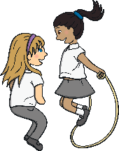
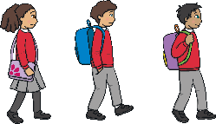
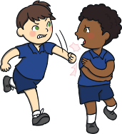
sharing
waiting
hitting

helping
sitting on the carpet nicely
shouting out
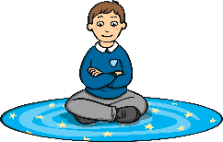
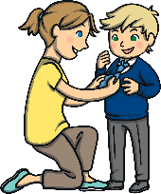
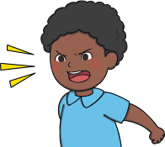

If I do not make good choices, the consequences could be:
- having time out;
- missing my playtime;
- completing work with the headteacher.
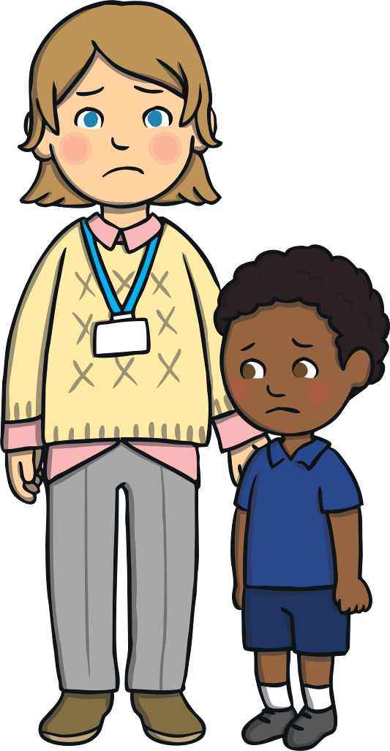

When I make a bad choice, there will be a consequence. This is when something will happen that I will not be happy about.
I must try to make good choices, even if other children do not.

